**What is Jenkins pipeline?**

Jenkins Pipeline is a script-based approach in Jenkins that allows defining and managing the entire CI/CD process, from building to deploying applications, as code. It provides flexibility, versioning, and reusability while integrating with various tools and plugins.

**2) What scripting language is Jenkins pipeline syntax based on?**

Jenkins Pipeline syntax is based on the Groovy scripting language.

**3) what are the different ways to trigger pipeline ?**

**Code Commit**: The pipeline can be triggered automatically when changes are pushed to a version control system, such as Git. This can be configured to trigger on specific branches or when certain criteria are met, such as a new tag or a pull request.

**Schedule:** Pipelines can be scheduled to run at specific times or intervals, allowing for regular automated builds or deployments. This can be useful for tasks like nightly builds or periodic deployments.

**Manual Trigger**: Pipelines can be manually triggered by a user or through an API call. This gives flexibility for on-demand execution, allowing developers or operators to trigger the pipeline when needed.

**Webhooks:** Jenkins can receive webhook notifications from external systems or services. When an event occurs in the external system, such as a build or deployment completion, it can trigger the Jenkins pipeline.

**Upstream/Downstream Pipelines**: Pipelines can be linked together, where the completion of one pipeline triggers the execution of another. This is useful when you have dependencies between different pipelines or stages.

**External Events**: Jenkins can listen to external events or triggers from other tools or systems. For example, a pipeline can be triggered when a new artifact is published to an artifact repository or when a specific condition is met in an external system.

Jenkins provides various plugins and integrations to support these triggering mechanisms, allowing for a flexible and customizable approach to pipeline execution based on the needs of the development and deployment workflow.

**4) what is different between parameter and jenkins env variable?**

Parameters: User-defined inputs for customization during job execution.

Environment Variables: Predefined or user-defined variables accessible throughout the entire job or pipeline execution.

5) what is organization folder job and what is used for ?

**6) Create jenkins pipeline for your repo and use script file (jenkinsfile) to write pipeline syntax, include parameter functions and env variable in it ?**

<https://github.com/Ali-ELHaggar/JenkinsLab02>

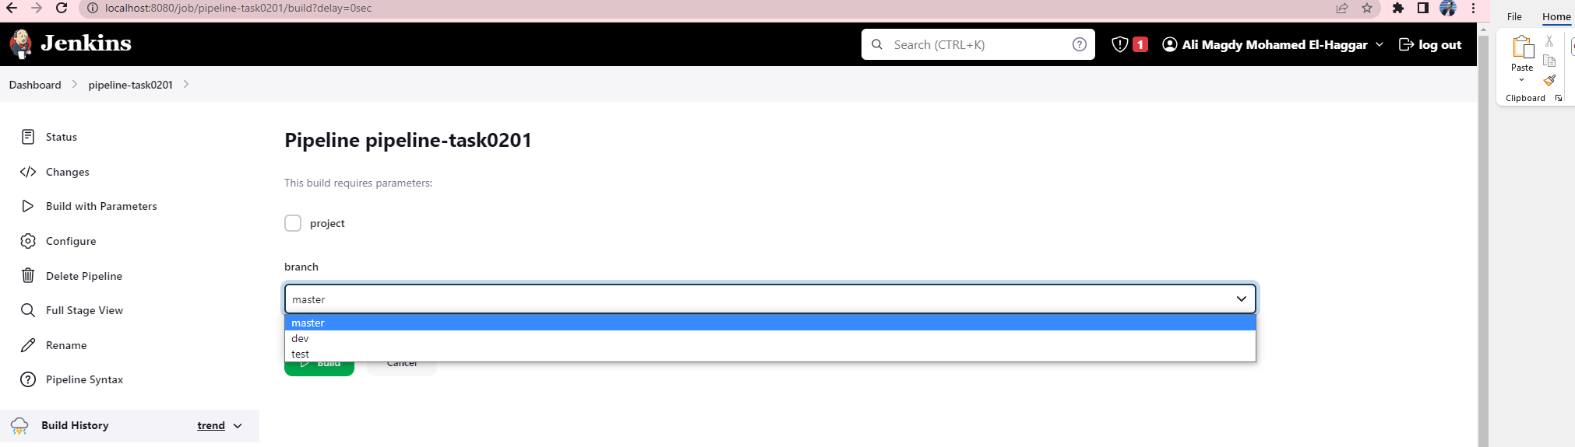

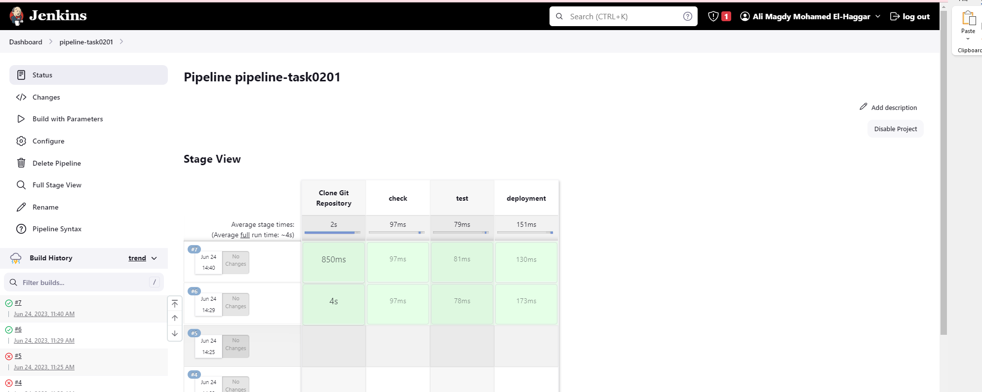

**7) Create another multibranch pipeline and filter branches to contain only (master , dev , test ) ?**

**Git Brabches:**

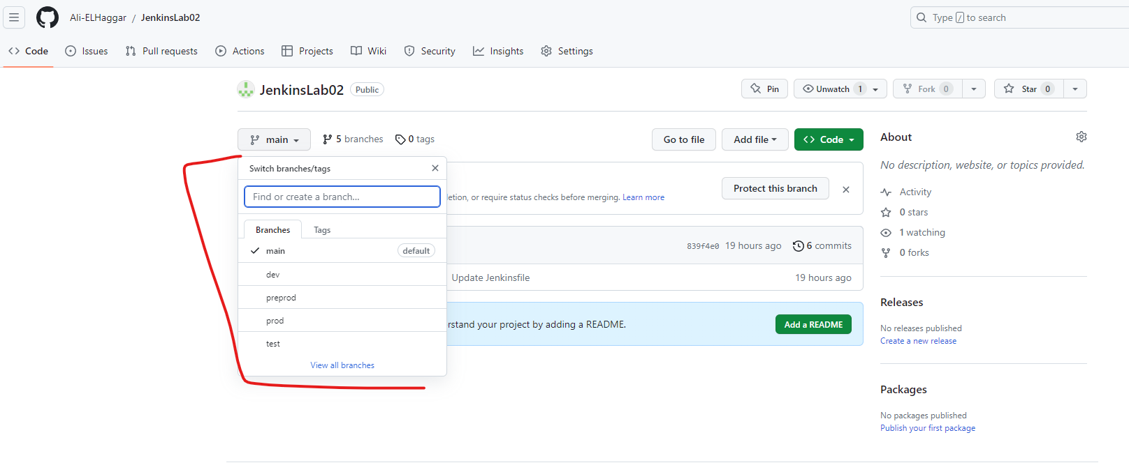

**Git Configuration.**

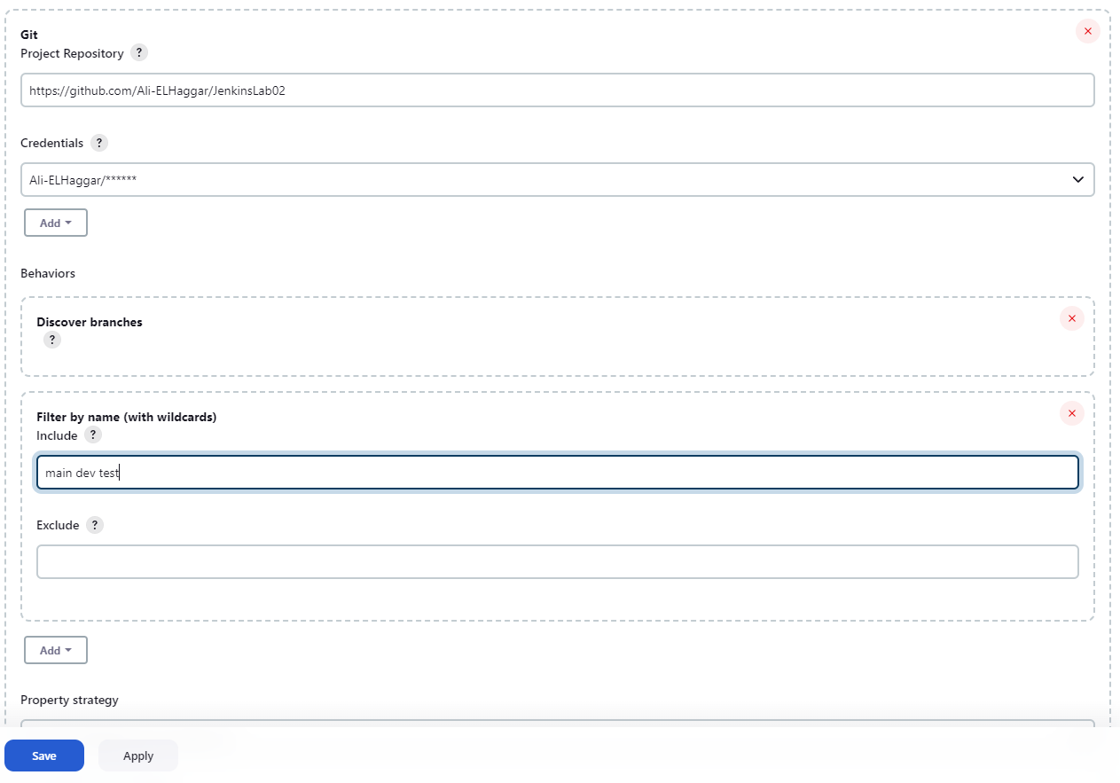

**Pipeline success log.**

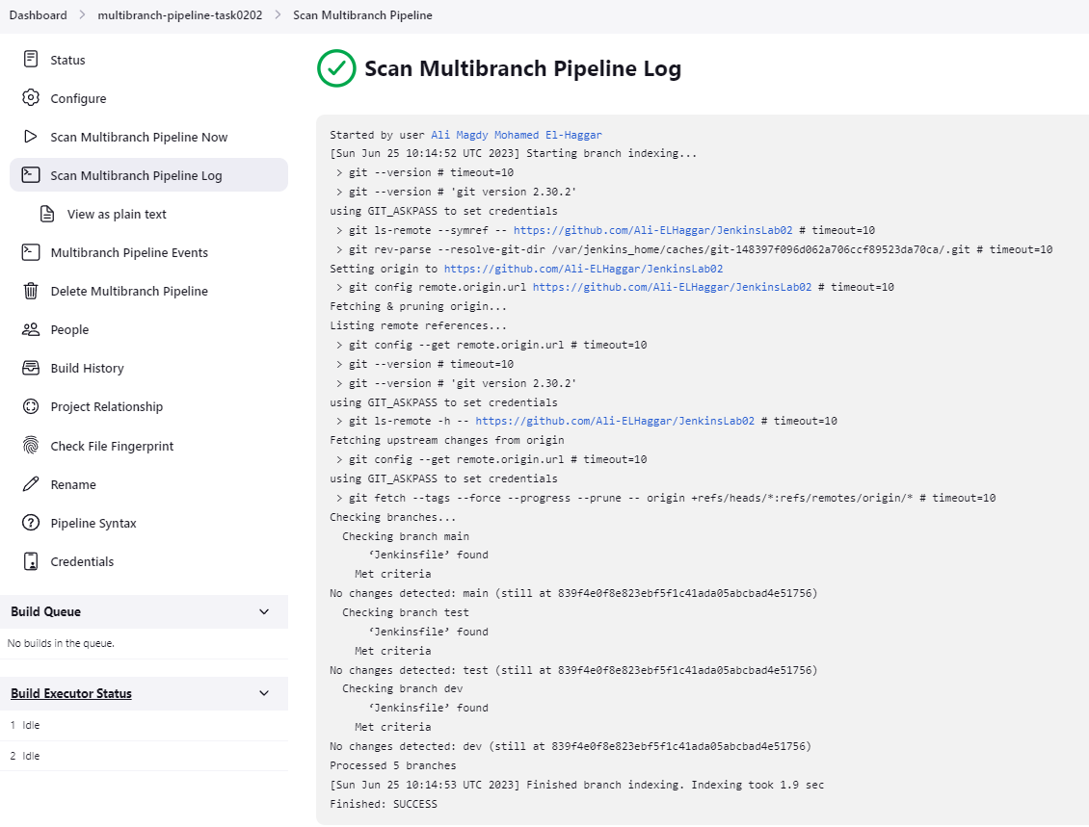

**PREPROD AND PROD EXCLUDED**

